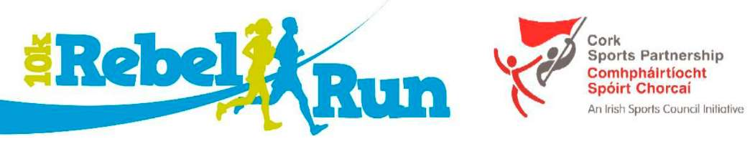

Cork

Sports Partnership Comhphdlrtlocht Spoirt Chorcai

An Irish Sports Council Initiative

w

While the concept of the Leisureworld Rebel Run 10Km is to provide the opportunity to take part in a well organised and fun event there are rewards for people who demonstrate high levels of fitness and ability in a number of categories. As a result the following prizes will be presented to participants:

(Prizes will be in the form of Sports Vouchers & spot prizes)

Main Category Prizes (Male & Female for 10k only)

1st Overall Prize €100 2nd Overall Prize €80 3rd Overall Prize €60

Age Category Prizes (Male & Female for 10k only)

Over 40 years 1st Place €40 Over 50 years 1st Place €40 Over 60 years 1st Place €40 Over 70 years 1st Place €40

Participant Prizes

(Awarded after the official results have been verified)

Further to the above list we will be giving a number of Spot Prizes to randomly Selected finishers in the 10k & 5k Events.

All online entries will be entered into a draw for a JOHN BUCKLEY SPORTS 'GAIT ANALYSIS AND

PAIR OF RUNNERS'

